Chapter 1: Units and Measurements

Physical quantity
- A quantity which is measurable, and understandable but not observable or touchable is called physical quantity.
- e.g. length, mass, time, speed, acceleration, force, work, pressure.

Types of physical quantities depending on direction:
- Scalars:
Those physical quantities which possess only magnitude and no direction such as temperature, mass, time, volume and speed of light are known as scalar quantities or scalars. direction in space
- Vectors:
Those physical quantities which have magnitude and direction both are called vector quantities or vectors such as velocity, acceleration, force etc.
SI unit
Physical Quantity | Formula | SI unit | MKS unit | CGS unit
Length |  | Meter(m) | Meter | centimetre
Mass |  | Kilogram(kg) | Kilogram | gram
Time |  | Second(s) | Second | second
Electric Current | $$I =\frac{q}{t}$$ | Ampere (A) | Colomb/second | Biot (Bi)  1 Bi = 10A
Temperature |  | Kelvin | Kelvin | Celsius
Amount of substance |  | Mole (mol) | Mol | ------
Luminous intensity |  | Candela(cd) | candela | Stilb(sb)

Derived Unit
Physical quantity | Symbol | Formula | MKS | CGS | Unit symbol
Area | A | Length * breadth | meter² | centimeter² | m²
Volume | V | L * b *h | meter³ | centimeter³ | m³
Density | $$ρ$$ | $$\frac{mass}{volume}$$ | $$\frac{kilogram}{{meter}^{3}}$$ | $$\frac{g}{{cm}^{3}}$$ | kg m³
Speed or velocity | v | $$\frac{Displacement}{time}$$ | $$\frac{meter}{second}$$ | cm/s | ms⁻¹
Acceleration | a | $$\frac{change in velocity}{time}$$ | $$\frac{meter}{{second}^{2}}$$ | cm/s² | ms⁻²
Force | F | Mass * acceleration | newton | Dyne | N
Work | W | Force * distance | joule | Erg | J
Power | P | Work/time | joule/s | erg/s | Js⁻¹
Pressure | P | Force/area | newton/ meter² | dyne/cm² | Pa
Linear Momentum | P | Mass*velocity | kilogram meter/second | gram cm/  second | kg ms⁻¹
Frequency | F | Vibration /second | second⁻¹ | second⁻¹ | Hz
Energy | E | Work | joule | Erg | J
Impulse |  | Force*time | newton second | dyne second | Ns
Surface Tension |  | Force/length | newton/meter | dyne/cm | Nm⁻¹
Coefficient of viscosity | $$η$$ | $$\frac{force*length}{area*velocity}$$ | pascal second | pascal second | Pa s
Coefficient of elasticity |  | Stress/strain | newton/meter² | dyne/cm² | Nm⁻²
Electric Current | I = q/t | Ampere (A) | coulomb/second | biot (bi)  1 bi = 10a | A

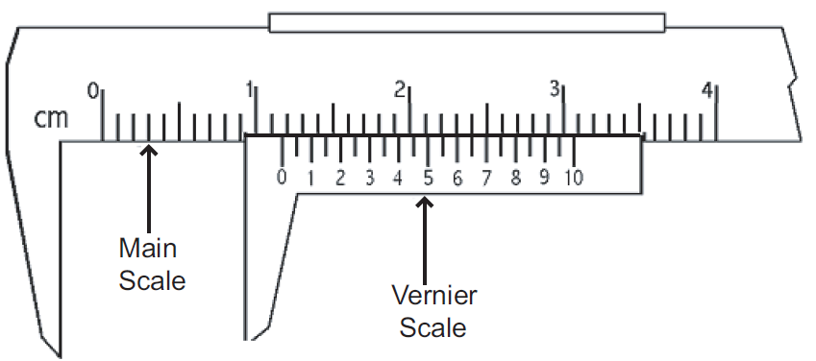
Vernier calliper
- The least count of vernier calipers is also known as the vernier constant. It is defined as the difference between one main scale division and one vernier scale division.
$$L.C.=\frac{Smallest division on main scale}{No.of division on vernier scale}$$
Use:
- Using vernier calipers one can measure diameter of solid cylinder, internal and external diameter of a hollow cylinder, thickness of a thin plate of glass of any material, and depth of liquid in a small vessel.
Method of Taking Reading:
- Determine the least count of the vernier calipers. Determine the zero error of the vernier. To determine the diameter of a given cylinder hold it between the jaws B & D and note down the reading as below:
- Note down the position of zero mark of the vernier. i.e. you have to note between which two consecutive division of the main scale zero mark of the vernier lies.
- Fig. shows that zero mark of the vernier lies between 1.1 and 1.2 cm i.e. the diameter of the cylinder is more than 1.1 cm but less than 1.2 cm. Note main scale reading as 1.1 cm.
- Now to find the remaining fraction, note the mark of the vernier that comes in line with any one of the marks of main scale. The number of this coincident mark of the vernier multiply by the least count gives the remaining fraction. This fraction will be 7 x LC = 7 x 0.01 cm = 0.07 cm. Note if as vernier scale reading. Sum of the main scale reading and vernier scale reading i.e. 1.1 + 0.07 = 1.17 cm gives the diameter of the cylinder.

Micrometer screw gauge
$$L.C.=\frac{pitch distance}{No.of division on circular scale}$$
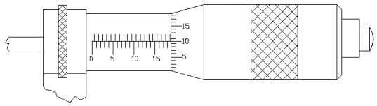
Use:
- Use of micrometer screw is to measure thickness of thin plate, diameter of steel balls, diameter of a thin wire etc.
Procedure for measurement of diameter of metal sphere:
- Hold the sphere, whose diameter is to be measured in between envil and end of the screw of micrometer, use retched for proper grip.
- Record main scale reading 'M.Sc.' (i.e. complete reading on main scale which we can see) and coinciding circular division number 'n' (i.e. circular division number which is exactly coinciding with main scale index line).
- Then total reading = M.Sc. + (n x L.C.) = 18.50 x mm + 10 (0.01) (As in Fig.)
=18.50 mm +0.1 mm = 18.60 mm

ERRORS
- Systematic Error:
  - During experiments systematic error is positive or negative. These errors cannot be both positive and negative. Reasons for systematic error can be known. So these errors can be reduced.

- Instrumental Error:
This error is due to defect in the instrument or defect in the calibration of scale e.g. One end of meter scale is broken, and then systematic error is created.
If scale of thermometer is not calibrated properly, systematic error is created.
- Errors due to imperfection in experimental technical or procedure:
This type of error is created due to procedure of experiment e.g. Temperature of body is taken by putting thermometer in armpit, which is less than true temperature of the body
- Personal Error:
This error is created due to procedure of taking reading by an individual, unproper arrangement of instruments carelessness.
- Error due to external reasons:
Temperature, pressure, moisture in air, velocity of air etc. can create error in taking readings in experiment.
- Random error
- Absolute error:
let a₁, a₂, a₃, ....a_{n} be value of measurement then
$$\overline{a }=\frac{a_{1}+ a_{2}+...+a_{n}}{n}$$
then, $∆a_{1}=\overline{a }-a_{1}$
$$∆a_{2}=\overline{a }-a_{2}$$
$$∆a_{n}=\overline{a }-a_{n}$$

- Mean absolute error
$$∆\overline{a}=\frac{\left|∆a_{1}\right|+\left|∆a_{2}\right|+…….+\left|∆a_{n}\right|}{n}$$
- Relative Error
$$δa=\frac{∆\overline{a}}{\overline{a}}$$
- Percentage error
$$δa*100\%=\frac{∆\overline{a}}{\overline{a}}*100 \%$$
Significant figures
Rules for determining the significant figures:
  - Only one uncertain figure should be retained in the measurement.
  - The zeroes on the left-hand side of a number are not significant e.g. if the reading is 0.043, it has only two significant figures.
  - The zeroes on the right side of a number are significant e.g. the reading 1.230 has four significant figures.
  - When a number is to be round off to a specific number of significant figures then –
- If the last figure is to be dropped is more of equal to 5, the last figure retained is increased by 1 i.e. 24.58 is written as 24.6.
- If the last figure to be dropped is less than 5, the last figure retained remains unchanged i.e. 22.54 is written as 22.5 if the last figure is to be dropped.

Some important conversions
- 1 N = 10⁵ dyne
- 1 Joule = 10⁷ erg
- 1 A⁰ = 10⁻¹⁰ m
- 1 AU = 1.496 × 10¹¹ m
- 1 a.m.u. = 1.66 × 10⁻²⁷ kg

DDCET questions
 |  | What is the S.I unit of power? (DDCET 2024)
 |  | a) | Joule | b) | Volt
 |  | c) | Watt | d) | Ampere
 |  | The pitch of micrometer screw is 0.5 mm. There are 50 divisions on its circular scale. What will be the least count of the screw? (DDCET 2024)
 |  | a) | 0.1 mm | b) | 0.001 mm
 |  | c) | 1 mm | d) | 0.01 mm
 |  | 10 dynes = _______ N (DDCET 2024)
 |  | a) | 10⁻⁵ | b) | 10⁻⁴
 |  | c) | 10⁵ | d) | 10⁷
 |  | What is the unit of Energy in CGS. (DDCET 2024)
 |  | a) | Newton | b) | Watt
 |  | c) | Joule | d) | erg
 |  | The refractive index of water is found to have the values 1.30, 1.32, 1.34, 1.35, 1.31. Calculate the mean absolute error. (DDCET -2024)
 |  | a) | 0.01254 | b) | 0.1254
 |  | c) | 1.254 | d) | 0.001254
 |  | Which instruments is used to measure inner diameter of the ring? (DDCET 2024)
 |  | a) | Vernier caliper | b) | Micrometer screw
 |  | c) | spherometer | d) | Physical balance
 |  | Number of significant digits in 2025 is (DDCET 2025)
 |  | a) | 3 | b) | 4
 |  | c) | 2 | d) | 5
 |  | Zero error is an example of ____ error (DDCET 2025)
 |  | a) | Systematic | b) | random
 |  | c) | Maximum | d) | Minimum
 |  | 1 joule = ____erg (DDCET 2025)
 |  | a) | 10³ | b) | 10⁵
 |  | c) | 10⁷ | d) | 10⁹
 |  | Density of water in CGS system is (DDCET -2025)
 |  | a) | 1000 | b) | 100
 |  | c) | 10 | d) | 1
 |  | In equation density S = $\frac{m}{V}$ if percentage error in mass m is 0.3% and for radius r is 0.5% then percentage error in density of a Sphere is _____ % (DDCET -2025)
 |  | a) | 1.8 | b) | 1.5
 |  | c) | 1.2 | d) | 1.1
12 |  | The pitch of micrometer screw is 1 mm. There are 100 divisions on its circular scale. What will be the least count of the screw? (DDCET 2025)
 |  | a) | 1 mm | b) | 0.1 mm
 |  | c) | 0.01 mm | d) | 0.001 mm
13 |  | SI unit of Linear momentum is _____ (DDCET 2025)
 |  | a) | Kg s / m | b) | Kg m/s
 |  | c) | m s / kg | d) | Kg s m
 | NOTES

Chapter 2: Classic Mechanic

Circular motion
Force:
- We can define force as: External effort in the form of push or pull which
- produces or attempts to produce motion in an object at rest,
- stops or tries to stop the object in motion,
- changes or tries to change the direction of motion of an object is called force.
- In all the above cases the external agency applies a force when an object is in contact. This type of force is called contact force.
- Friction force, Normal force, Air resistance, Tension force, spring force are examples of contact forces.
- An external agency exerts a force even if it is not in contact with the object. These types of forces are called non-contact forces or field forces.
- Magnetic force, electrostatic force, gravitation force are examples of field forces.

Units of Force:
- Force = Mass × Acceleration
- SI unit of force is newton (N) and the cgs unit is dyne.

Linear Momentum:
- The linear momentum of a body is defined as the product of the mass of the body and its velocity.
Linear momentum = mass × velocity
SI unit: kg ms⁻¹
- In considering the effect of force, linear momentum is very important. This can be understood from the following examples:
  - We know that a much greater force is required to push a truck than a car to bring them to the same speed in the same time. Similarly, a greater opposing force is needed to stop a heavy body than a light body in the same time, when they are moving with the same speed. Thus, the mass of a body is an important parameter that determines the effect of force on its motion.
  - Speed is another important parameter to consider. A bullet fired from a gun can easily pierce through a target like human tissue, before it stops, resulting in grave injury. The same bullet, thrown with a moderate speed can be easily stopped. Thus, for a given mass, greater is the speed, greater is the opposing force needed to stop the body in a certain time.
- Taken together, the product of mass and velocity, i.e., linear momentum is an important quantity, when we consider effect of force on its motion.

Impulse and its Applications:
- When a large force acts on a body for a short interval of time then the body is said to be subjected to impulse.
- e.g. Hammer struck on a nail, the ball struck by a bat.
- The product of force and time during which force acts called impulse of force.
Impulse of force = F × dt
Impulse of force = Change in momentum
- The forces which act on bodies for short time are called impulsive forces.
Impulse of force = force x time
- SI unit of impulse of force is Newton –second or Kg ms⁻¹
- Impulse is a vector quantity.

Applications of Impulse of a Force:
- A cricket player lowers his hands while catching a cricket ball. As you may have noticed, the player draws in his hands backward in the act of catching the ball. Thus, he allows a longer time for his hands to stop the ball.
Therefore, by increasing the time of a catch, the player has to apply a smaller force against the ball in order to stop it. The ball in turn, exerts a smaller force on his hands and his hands are not injured.
- When a person falls from a certain height on a cemented floor, the floor does not yield. The total change in linear momentum is produced in a smaller interval of time. Therefore, as explained above, the floor exerts a much larger force. Due to it, a person gets more injury
- Chinawares and glasswares are wrapped in paper or straw pieces while packing. In the event of fall, impact will take a longer time to reach the glass/chinawares through paper/straw. As a result, the average force exerted on the China or glasswares is small and chances of their breaking reduce.
- The vehicles like scooter, car, bus, truck etc. are provided with shock-absorber When they move over an uneven road, impulsive forces are exerted by the road. The function of shock-absorber is to increase the time of impact. This would reduce the force/jerk experienced by the rider of the vehicle.
- Bogies of a train are provided with the buffers. They avoid severe jerks during shunting of the train. Due to presence of buffers, time of impact increases. Therefore, force during jerks decreases. Hence the chances of damage decrease.

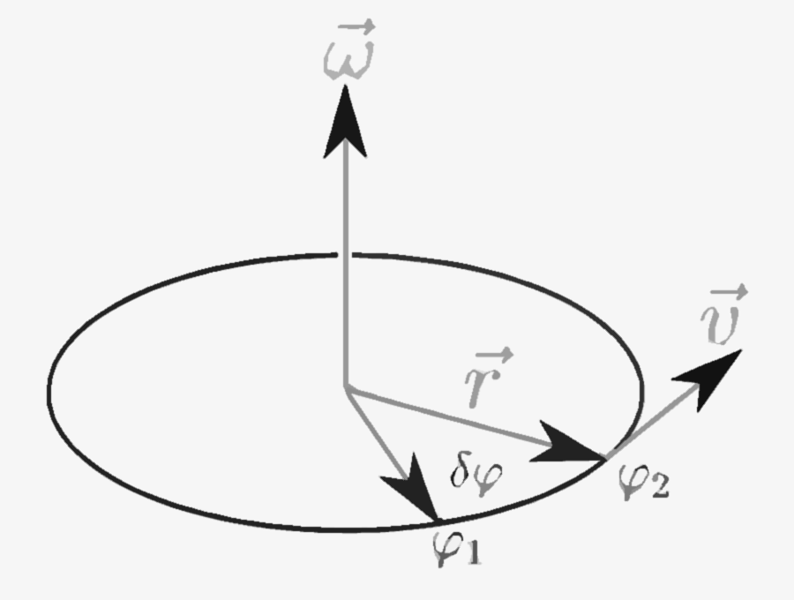
Angular Velocity:
- The angle described by a rotating body per unit time is called its angular velocity and is denoted by the Greek letter $ω$ (omega)
$$ω= \frac{Angular displacement}{time}$$
$$ω= \frac{θ}{t} rad/s$$
- The angle is measured in radians i.e.
$$θ= \frac{arc AB}{radius of circle}=\frac{S}{r}$$
- Now angular Velocity
$$ω= \frac{θ}{t}=\frac{2π}{t}=2πf$$

Relation Between Angular and Linear Velocity:
- Let us assume that the body as shown in Fig. travels on circular path with uniform speed v. If the angle described is $θ$ and the distance traversed is S in time t i.e., if the body takes t seconds for going from A to B, we have Speed
$$v= distance/ time = S/t$$
- Substituting the values S = r*$θ$ in above equation
$$V=\frac{rθ}{t}$$
$$ω=\frac{θ}{t}$$
$$v=rω$$
- In the above equation $ω$ is the angular velocity in radians per second.

Centripetal force:
- When an object moves in a circular path with constant velocity, its direction changes at every moment. According to Newton's law of motion, any object is unable to change its direction. Thus, in order to keep an object in a circular motion, force has to be applied to change its direction without changing its magnitude of velocity.
- Thus, this force is applied pointing to the center by radius which is called centripetal force.
- The force exerted by the radius towards the center of a circle which makes an object move in a circle path with uniform speed is called centripetal force.
$$Centrifugal forrce=\frac{mv^{2}}{r}=\frac{m{(rω)}^{2}}{r}=mrω^{2}$$

Examples of Centrifugal and Centripetal Forces:
- The force of friction between the road and the tire provides the desired centripetal force when the motor car moves on a circular road. This frictional force balances the centrifugal force. Friction seems to be less if the road is too smooth. As a result, the motorcar skids off. For this the inner edge of the road is kept slightly lower than the outer edge. Thus, curved roads are made sloping.
- Mudguard in bicycle (mud guard): When a bicycle is moving on the road, mud, dust etc. stick the tire and it flies tangentially as the speed increases. As a result, the rider's clothes get spoil. That's why Mudguards are kept on the tires.
- Bending of cyclists at curved roads are also examples of centripetal force and centrifugal force.

DDCET questions
1 | The mathematical expression for Newton’s second law is (DDCET 2024)
 | a) | F = mv | b) | P = mv
 | c) | F = ma | d) | P = ma
2 | Find the acceleration produced by applying a force of 30N on an object of mass of 5 kg  (DDCET 2024)
 | a) | 0.6 m/s² | b) | 6 m/s²
 | c) | 6 m/s | d) | 0.6 m/s
3 | _______ are the examples of impulse of force. (DDCET 2024)
 | a) | China wares are wrapped in paper while packing | b) | Bogies of a train are provided with the buffers.
 | c) | Both A and B | d) | None of the above
4 | A body is moving in a vertical circular motion, which one of the following forces does not experience? (DDCET 2024)
 | a) | Force of gravity | b) | Centripetal force
 | c) | Friction force | d) | Centrifugal force
5 | ________ is the field force. (DDCET 2024)
 | a) | Gravitational Force | b) | Magnetic force
 | c) | Electrical force | d) | All of the above
6 | The work done by the external forces on a system equals the changes in (DDCET 2024)
 | a) | Total energy | b) | Kinetic energy
 | c) | Potential energy | d) | None of these
7 | the centripetal force always acts (DDCET 2025)
 | a) | Away from the centre | b) | In tangential direction
 | c) | Perpendicular to the motion | d) | Towards the centre
8 | When external force acting on a body is zero then its acceleration is (DDCET 2025)
 | a) | Increases | b) | Decreases
 | c) | Equal to zero | d) | Remains constant
9 | The formula for angular velocity of a body moving with a constant speed v in a circle of radius r is given by (DDCET 2025)
 | a) | v/r | b) | Vr
 | c) | vr² | d) | vr³
10 | A body having 10 kg mass and 9.8 m/s² acceleration produces how much force?  (DDCET 2025)
 | a) | 9.8 newton | b) | 98 newton
 | c) | 0.98 newton | d) | 980 newton
11 | If an object having mass 50 kg rotated in a circle with a radius of 2 m with a constant speed of 60 m/s then what is the value of centripetal acceleration? (DDCET 2025)
 | a) | 6000 m/s² | b) | 3000 m/s²
 | c) | 1800 m/s² | d) | 1500 m/s²

NOTES
Chapter 3: Heat and Thermometry

Definition of Heat (Heat energy):
- It is the transfer of energy between two objects or an object and its surroundings due to temperature difference.
SI unit: | Joule
CGS unit: | Erg

Modes of Transfer of Heat:
There are three different modes of transfer of heat
(1) Conduction (2) Convection and, (3) Radiation.

- Conduction:
- The process in which heat is transferred along a body, from a part of higher temperature to that lower temperature without bodily movement of body from a part medium is called conduction.
- When a metal rod is heated at one end, the opposite end of the rod gets heated after sometime. On this case the molecules of the rod do not move from their positions, but the heat travels from one end of the rod to the other.
- The molecules of every solid are continuously vibrating about their mean positions. The vibrations of molecules increase with supply of energy.
- The molecules of the metal rod near the source of heat are the first to receive heat. As soon as they receive heat, they begin to vibrate vigorously. These molecules collide with the molecules in the neighboring layer and part with some of the heat energy possessed by them. Having received additional energy, the molecules in this layer also begin to vibrate vigorously and in turn give some of the energy with them to the next ones. In this way heat travels along the rod.
- The molecules of the solids are held rigidly in their mean position; hence conduction is the only mode of transfer to the heat in solid.

- Convection:
- In thermal convection the constituent particles actually move from one place to another. This fact indicates that the convection is observed only in gases and liquid i.e. fluid
- In convection, fluid at the bottom becomes hot and so its volume increases, due to which its density decreases. So, due to buoyant force this 'lighter' fluid moves upwards and due to gravitational effect, the fluid with greater density is transferred from the top to the bottom. Due to such a continuous process the fluid is heated. If you add potassium permanganate into water while heating it in a flask you can observe this phenomenon.
- Convection can be natural as well as forced. If the motion of the material is only due to the difference in density it is natural convection e.g. 'cool current' near a sea shore. The soil becomes hot due to sun rays and so the air in contact with this soil also gets heated and its volume increase and its density decreases. So, this air is moving up. So, the air pressure near the soil reduces due to which the cool air from sea side rushes towards the soil. Thus, cool currents of air are formed. During night it reverses.
- In forced convection a fluid is forced to move using some appliance, like a pump, or a stirrer. In human body heart acts as a pump for blood circulation. Due to this blood circulation body temperature is maintained.

- Radiation:
- Every substance emits electromagnetic radiation of certain frequencies in accordance with its temperature. These radiations are thermal radiations. Thermal radiations are electromagnetic radiations only. The energy associated with this electromagnetic radiation is called radiant energy.

Anomalous expansion of water:
- The volume of water increases instead of decreasing when temperature of water is reduced from 4°C to 0°C. This is called anomalous expansion of water.
- The existence of fish and other aquatic animals is possible because of natural convection and anomalous expansion of water.
- In winter, as temperature decreased, upper layer of water converts into ice and stops the heat from below layers to atmosphere. So below the ice layer, there is temperature at 4°C and fish and other aquatic animals can survive.

TEMPERATURE MEASUREMENT SCALE
- Celsius scale:
$$T_{C}=T_{K}-273$$
- Fahrenheit scale:
$$T_{F}=\frac{9}{5} T_{C}+32$$
- Kelvin temperature scale:
$$PV = n RT$$
Where R = universal gas constant = 8.31 J mol⁻¹ K⁻¹

Heat capacity
- The ratio of heat Q supplied to a body to a change in its temperature $∆$T is called heat capacity Hc of the body.
$$H_{C}=\frac{Q}{∆T}$$
- SI unit: J K⁻¹ (Joule/Kelvin)

Specific Heat
- The quantity of heat required per unit mass for unit change in temperature of a body is called the specific heat of the material of the body.
$$Specific heat = \frac{Heat capacity}{mass}$$
$$C=\frac{H_{c}}{m}=\frac{Q}{∆T m}$$
- The unit of specific heat is J kg⁻¹ K⁻¹

Thermal conductivity
- Thermal conductivity is a measure with which heat flows through a material. In the process of conduction, heat is transferred from one particle to another through molecular vibration and energy transfer via free electrons

Co efficient of Thermal conductivity
The quantity of heat conducted depends upon following factors
- The quantity of heat conducted is directly proportional to the cross-sectional area of the rod
$$Q ∝ A$$
- The quantity of heat conducted is directly proportional to the temperature difference between the planes.
$$Q ∝ (θ_{1} – θ_{2})$$
- The quantity of heat conducted is directly proportional to the time of flow
$$Q ∝ t$$
- The quantity of heat conducted is inversely proportional to the distance between the planes.
$$Q ∝ \frac{1}{d}$$
- Combing all factors, we get
$$Q∝\frac{A\left(θ_{1}-θ_{2}\right)t}{d}$$
$$Q=K \frac{A\left(θ_{1}-θ_{2}\right)t}{d}$$
$$K=\frac{Qd}{A\left(θ_{1}-θ_{2}\right)t}$$
- K is constant, known as coefficient of thermal conductivity, its value depends upon the material of the rod.
- Unit of Thermal Conductivity:
C.G.S.: | Cal/cm °C S
M.K.S.: | K-Cal/m° C S
SI: | Watt/mk
Applications of thermal conductivity:
- Ceiling of house is made up to concrete and conducts more heat. To reduce conduction of heat, wall of brick is prepared on the outer side of ceiling and prepared false ceiling of Plaster of Paris (POP) inside the ceiling. Thus, house is kept cool by reducing heat conduction from outside.
- Metal handles in door are felt cool in winter and tiles as well as steel vessels are also felt cool in winter.
- Wood and air are bad conductors of heat. If ice is kept in wood, it does not melt for longer time.
- New blanket gives more heat to human body as air is trap in blanket as compared to old blanket. Two thin blanket gives more heat than one thick blanket.
- Handles of tea-pot and cooker are of rubber or wood as they are bad conductors and remaining parts are of metal as metal is good conductors to heat.

Coefficient of linear expansion:
- If object is of rod shape and temperature difference is small, the change in rate of length $\frac{∆l}{l}$is proportional to T.
$$\frac{∆l}{l}∝∆T$$
$$\frac{∆l}{l}=α_{l} ∆T$$
- Here $α_{l}$ is known as coefficient of linear expansion. It is the property of matter. Generally, expansion is more in metals and their value of $α_{l}$ is high.
- Unit: K⁻¹ or °C⁻¹

DDCET questions
 | At what temperature are Celsius and Fahrenheit equal? (DDCET 2024)
 | a) | 40⁰C | b) | 40⁰F
 | c) | -40⁰C and -40⁰F | d) | None of the above
 | Unit of heat capacity is (DDCET 2024)
 | a) | J/K | b) | Cal/K
 | c) | Cal/⁰C | d) | All of the above
 | With rising temperature, the thermal conductivity will be (DDCET 2024)
 | a) | Decreased | b) | Increased
 | c) | Remain constant | d) | zero
 | The mathematical formula of specific heat is (DDCET 2024)
 | a) | C = Q /mΔT | b) | Q = C /mΔT
 | c) | Hc = Q /ΔL | d) | Q = Hc /ΔL
 | A person is having temperature of 104⁰F. convert it in Celsius (DDCET 2024)
 | a) | 38⁰C | b) | 40⁰C
 | c) | -40⁰C | d) | -38⁰C
 | A big piece of glass is first heated and then is allowed to cool. On cooling down, a crack is developed in it. One of the possible reasons for this is (DDCET 2025)
 | a) | High melting point | b) | Large thermal conductivity
 | c) | Large specific heat | d) | Small thermal conductivity
 | When heat is given to boiling water, the temperature of water (DDCET 2025)
 | a) | Increases | b) | Decreases
 | c) | Remain constant | d) | None of the above
 | 37⁰C = _____⁰F (DDCET 2025)
 | a) | 98.6 | b) | 98.8
 | c) | 97.6 | d) | 96.8
 | The SI unit of coefficient of thermal conductivity is (DDCET 2025)
 | a) | J / mK | b) | N / mK
 | c) | W / mK | d) | m K /W
 | Heat capacity of a body per unit mass is known as (DDCET 2025)
 | a) | Specific heat | b) | Relative heat
 | c) | C_{p} | d) | C_{v}
 | 1 Kcal = ______J (DDCET 2025)
 | a) | 4.186 | b) | 4186
 | c) | 41.86 | d) | 418.6

NOTES
Chapter 4: Wave Motion Optics and Acoustics

Definition of waves
- Wave is a disturbance propagating in a medium in which medium particles are in simple harmonic motion Disturbance progresses but medium particles do not leave their position.
- Waves mean propagation of wave.

Types of waves:
- Mechanical Waves:
These waves need elastic medium to propagate.
The medium particles take part in propagation of wave
e.g. waves in a string (medley experiment), sound waves in air, sound waves in glass or water (liquid).
- Non-Mechanical Waves:
These are energy waves.
No need of medium is required for these waves.
Electromagnetic waves like light, X-ray are these types of waves

Types of waves based on motion:
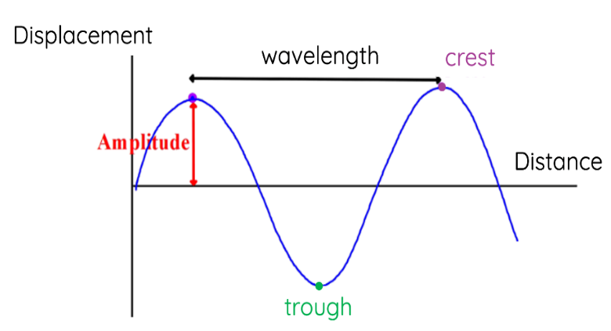
- Transverse Waves:
- Transverse wave can be defined as a wave motion in which the particles of the medium vibrate about their mean position at right angles to the direction of propagation of wave.
- e.g. light waves, water waves, when a stone is dropped in water, waves in rope when one end is tied on the support and another end is taken up and down repeatedly
- Longitudinal waves:
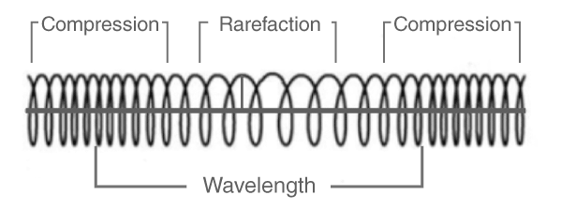
- Longitudinal wave can be defined as a wave motion in which the particles of the medium vibrate about their mean position along the same line as that of propagation of the wave
- e.g. sound waves.
Transverse Waves: | Longitudinal waves
- The particles of the medium vibrate in the direction perpendicular to the direction of propagation of the wave. | - The particles of the medium vibrate in the direction parallel to the direction of propagation of the wave.
- The wave travels in the form of crest and troughs. | - The wave travels in the form of compressions and rarefactions.
- Requires elasticity of shape for its maintenance. | - Requires elasticity of volume for its maintenance.
- The wave is possible in solid media only. | - The wave is possible in liquids and gases.
- The medium undergoes deformation of shape. | - The medium undergoes deformation of volume.
- There is no change in the density and pressure of the medium. | - There is a change in the density and pressure of the medium.
- The waves can be polarized | - The waves cannot be polarised.
Periodic time (T):
- It is the time required to complete one vibration.
- Unit: second.
$$T=\frac{1}{f}$$
Frequency (f):
- It is the number of vibrations performed by the particle in one second.
- Unit: hertz.
Wavelength (λ):
- The distance between two consecutive particles in the same phase is called wavelength.
- Unit: meter
- Generally, wavelength is expressed in Angstrom unit.
- 1 A° = 10⁻¹⁰ meter = 10⁻⁸ cm

Relation Between Velocity, wavelength and frequency.
$$Velocity =\frac{Distance travelled}{time}$$
$$V=\frac{λ}{T}$$
$$V=λf$$

Reverberation:
- The presence of sound in an enclosure even after the source is shut off, is called reverberation.

Reverberation time:
- The time during which the energy density of the sound falls to millionth (10⁻⁶) of its initial value after the source is shut off, is called reverberation time.

Optimum time of reverberation for auditorium.
- Depending upon type of sound, volume and design of the auditorium, the reverberation time is kept 0.5 to 2.3 second.
- The reverberation time for lecture is kept 1.03 second.
- The reverberation time for musical sound is kept 1.5 to 1.7 second.
- If reverberation time is less than 0.5 second, the auditorium is felt dry.
- If reverberation time is more than 2.3 second, the sound becomes confused and not understandable.

ECHO:
- When a sound wave is incident on a obstacle, a part of it is reflected and a part is absorbed.
Coefficient of Absorption of Sound
$$Coefficient of Absorption of Sound=\frac{sound energy absorbed by the surface}{total sound energy incident on the surface}$$
- Unit: open window unit (O.W.U) or Sabines

Sabine’s Formula for reverberation time:
$$t=\frac{0.161 V}{\sum{aS}}$$
where V = volume of hall
a = coefficient of absorption for reflecting surface
S= surface area of the reflecting surface

Factors affecting Reverberation of time and acoustics of building:
- Reverberation | - Reverberation
- Adequate Loudness | - Adequate Loudness
- Focusing due to wall and ceilings | - Focusing due to wall and ceilings
- Resonance | - Echoes
- Echelon effect | - External noise

Ultrasonic Waves:
- The sound waves having frequencies more than 20,000 Hz are known as ultrasonic waver.
- The sound waves having frequencies less than 20 Hz are called infrasonic waves. The sound waves having frequency range between 20 Hz to 20,000 Hz are audible to human body.
- A device in which electrical oscillations are converted in to sound energy is called transducer
- The transducer producing ultrasonic waves is called ultrasonic transducer. There are two important methods namely magnetostriction and piezoelectric method which are mostly used now-a-days.
Properties of ultrasonic waves:
- They are nothing but acoustical waves with frequency higher than 20 kHz.
- They are highly energetic.
- They show negligible diffraction due to their small wavelength. Hence, they can be transmitted over long distance without any appreciable loss of energy.
- Intense ultrasonic radiation has a disruptive effect in liquids by causing bubbles.
- They are longitudinal waves.
- Wavelength or ultrasonic waves is small.
- We cannot hear these waves.
- Some animals, mosquitoes, insects and birds can hear these waves.
- Dogs can hear the waves so Dog's whistle is prepared.
- They travel in homogeneous medium with constant velocity.
- When they travel in medium, they produce heating effect.
- Reflection, Refraction, absorption as same as sound waves.
- They work as catalyst to accelerate chemical reactions.
- When they pass through liquids, they create stationary wave patterns

Application of Ultrasonic Waves
- Applications of Ultrasonic Waves in Science and Engineering Field
- Used in cleaning the objects with parts those are difficult to reach.
- Used to detect defect or cracks in metals.
- Used to detect ships, submarines, iceberg in the ocean (using SONAR-Sound Navigation and Ranging device).
- Used for soldering aluminum coil capacitors, aluminum wires and plates without chemical flux.
- Used to weld some metals which cannot be welded by electric or gas welding.
- Used for cutting and drilling holes in metals.
- Used to form stable emulsions of even immiscible liquids like water and oil or water and mercury which are used in preparation of photographic films, face creams etc.

- Applications of Ultrasonic Waves in Medical field
- Used to remove kidney stones and brain tumors without shedding any blood.
- Used to take images of our internal body structures such as muscles, joints and internal organs.
- Used to remove broken teeth.
- Used for sterilizing milk and killing bacteria.
- Used to study the blood flow velocities in blood vessels of our body.
- Used as a diagnostic tool to detect tumors, breast cancer and also the growth of fetus.

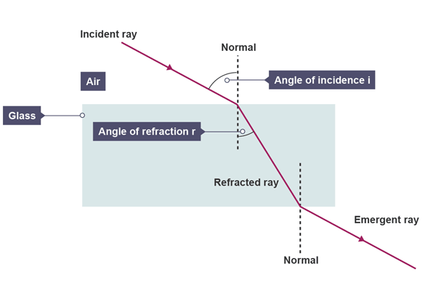
Refraction:
- When a ray of light is travelling from one medium to another medium, it changes its direction of travelling at the contact surface of the two mediums. This phenomenon is called refraction.

Laws of Refraction
- Incident ray, normal and the refracted ray are in the same plane.
- Incident ray and refracted ray are in different media
- Ratio of sine of angle of incidence to sine of the angle of refraction is constant for the given two media. It is termed as "Refractive Index (μ)"

Snell's law
- The ratio of the sine of the angle of incidence to the sine of the angle of refraction is a constant for a given pair of media. This constant is known as the refractive index.
$$μ=\frac{\sin{i}}{\sin{r}}$$
- Refractive index for a given medium can also be obtained by the ratio of speed of light in air to the speed of light in given medium.
$$μ=\frac{C}{V}$$
Where C = Speed of light in air or vacuum = 3 × 10⁸ m/s
V = Speed of light in given medium
Material | Refractive index
Air | 1.00
Water | 1.33
Glass | 1.50
Dimond | 2.42

Total Internal Reflection of Light:
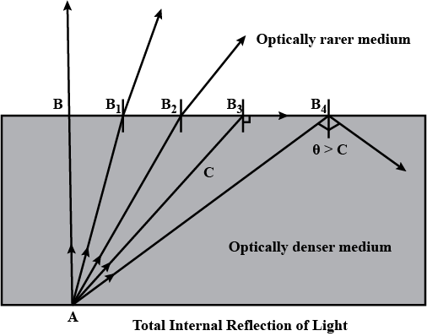
- Consider the case of a light sources placed in a medium of higher refractive index say water and emitting light rays in all directions as shown in figure.
- We know that when a ray of light passes from an optically denser to a rarer medium, the refracted ray is bent away from the normal i.e. the angle of refraction is greater than the angle of incidence.
- First of all, we consider a ray SB striking the interface at an angle i it is refracted at an angle r₁. Obviously $∠$r₁ > $∠$i.
- As the angle of incident increase the angle of refraction also increases till for a particular angle of incidence the refracted ray emerges along the surface of separation. This particular angle is known as critical angle.
- Now next we consider the ray SD which is incident on critical angle and hence it is refracted along the boundary of separate ray SD which is say is incident at an angle greater than critical angle $∠$M, no refraction occurs and the incident is reflected in the same medium, i.e. water. This phenomenon is called as total internal reflection.
Necessary conditions for total internal reflection:
- The light must be travelling from high dense medium into a less dense medium (i.e. glass to air).
- The angle of incidence must be greater than the critical angle.

LASER
- We know that electrons revolve round the nucleus in certain orbits, and stable and neutral atom is created.
- When energy is given from outside, electron revolving in the orbit absorbs this energy and jumps from lower energy level to upper energy level and hence atom is called exited.
- Electron cannot remain in exited states for longer time. It comes back to ground state within 10⁻⁸ second emitting energy as photons. This way electron absorbs and emits energy as photons.
- Thus, when electron jumps from lower energy level E₁ to higher energy level E₂, energy absorbed is
$$ΔΕ = Ε2 - Ε₁ = hv$$
Where h = planks constant
v = frequency of photon
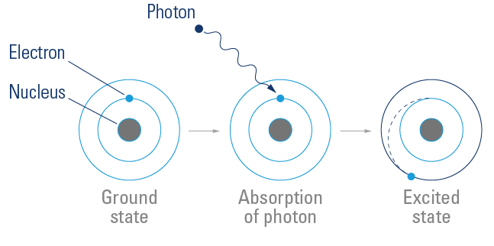
- LASER full form Light Amplification by Stimulated Emission of Radiation
- A laser beam is extremely energetic and extremely parallel.
- Laser beam in quanta of highly intense, concentric coherent monochromatic photons of light with tremendous speed with same phase.

Types of Lasers (just for reference)
- Solid State Laser:
- In solid state lasers, the lasing material distributed in a solid matrix.
- Examples: Ruby laser
- Gas Laser:
- The gas lasers have a primary output of a visible red light.
- Examples: Helium-Neon (He-Ne) laser, CO2 laser, Argon-ion laser etc.
- Excimer Laser:
- The excimer lasers use reactive gases such as chlorine and fluorine mixed with inert gas such as argon, krypton, or xenon.
- Examples: Hydrogen fluoride, Nitrogen tri-fluoride etc.
- Dye Laser:
- The dye lasers use complex organic dyes like rhodamine 6G in liquid solution or suspension lasing media.
- Semiconductor Lasers:
- The semiconductor lasers are also known as diode lasers. These electronic devices are generally very small and use low power. They may be built into larger arrays.
- Examples: Laser diode used in laser printers, CD players etc.

Applications of Laser Applications of LASER in Engineering Field
- Used in optical fiber communication.
- Used in laser printer.
- Used in bar code scanner and image scanning
- Used in CD players and DVD players.
- Used in optical data recording.
- Used in object tracking like missile, aero plane, etc.
- Used in industrial applications like heat treatment, cutting, welding etc.
- Used in distance measurement.

Applications of LASER in Medical Field
- Used in laser surgery of eye. | - Used in cosmetic surgery
- Used in removing tumors. | - Used in beauty therapy.
- Used in hair removal. | - Used to remove Kidney stone.
  - Used to remove tattoo from body

Ordinary Light | LASER light
- The ordinary white light is a combination of many different wavelengths (colors). | - The laser light is monochromatic. It means it is of one wavelength (colors).
- The ordinary light coming from the sun, a light bulb or a candle is emitted in many directions away from the source. | - The light emitted by the laser highly directional.
- The ordinary light is incoherent. | - The laser light is highly coherent.
- The ordinary light does not contain the photons of same frequency. | - The laser light is the focused beam in which all photons move at same wavelength.
- The ordinary light is spread out in all directions. So, its intensity is less. | - The laser light is concentrated in a beam of small
Optical Fiber
- An optical fiber is a thin, flexible, transparent strand meant for communicating light signals through it.
- It is based on the principle of total internal reflection.
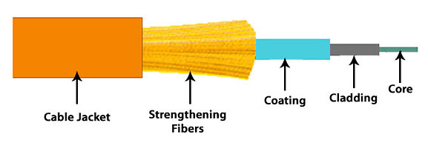
- Light once trapped within the fibre continues to move along the length of fibre without being lost.
- When light enters one end of the fibre, it undergoes successive total internal reflections from side walls and travel down the length of the fibre along a zigzag path.
- The optical fiber consists of a core at the centre and a cladding outside the core.
- The core is generally cylindrical dielectric glass with a refractive index n, and the cladding is the second sheath or cover made of glass with a lower refractive index n, than the core refractive index.
- The cladding is covered by a buffer jacket called sheath.
- Surrounding this jacket there is a layer of strength members called Kevlar (a yarn-type material) which increases the tensile strength of the cable.
- Again, an outer protective tube is filled with polyurethane, which prevents moisture from coming into contact with the fiber.

Types of Optical Fiber based on mode of propagation.
- Step index
- Graded index
Applications of Optical Fiber Cable
- Applications of Optical Fiber Cable in Engineering Field
  - Used in telecommunication for short as well as long distance.
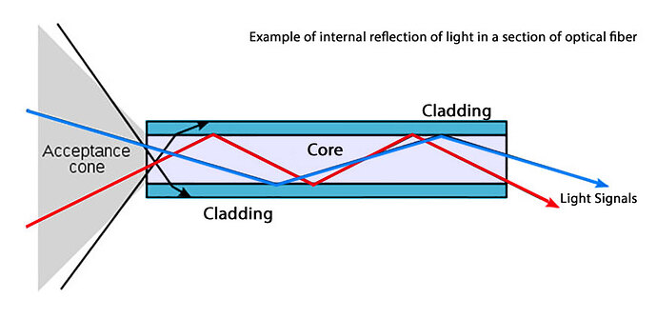
  - Used in digital data transmission in internet.
  - Used in computer networking.
  - Used in cable television.
  - Used in video telephony and video conferencing.
  - Used in mechanical inspections.
  - Used in illumination applications.
  - Used in military and aerospace applications.
  - Used in lighting and decoration’s purpose.
  - Used for testing and research purpose.
- Applications of Optical Fiber Cable in Medical Field
  - Used as laser in surgery, endoscopy, microscopy etc.
  - Used to see internal body parts by inserting into hollow spaces in the body.
  - Used in biomedical testing and research.
  - Used in MRI, CT scan etc.
DDCET questions
 | Which of the following is not a type of electromagnetic wave? (DDCET 2024)
 | a) | Sound wave | b) | Light wave
 | c) | Gamma ray | d) | Micro wave
 | Which type of wave is a light wave? (DDCET 2024)
 | a) | Longitudinal | b) | transverse
 | c) | Both A and B | d) | None of the above
 | the frequency of sound wave is 2KHz and its wave length is 2 m. What is the speed of sound wave? (DDCET 2024)
 | a) | 2000 m/s | b) | 400 m/s
 | c) | 200 m/s | d) | 4000 m/s
 | _________ is not the characteristics of LASER. (DDCET 2024)
 | a) | Coherent | b) | Monochromatic
 | c) | Divergent | d) | High intensity
 | Optical fibre works on the principle of (DDCET 2024)
 | a) | Total internal reflection | b) | polarization
 | c) | Divergent | d) | High intensity
 | A volume of an auditorium is 6000 m³. The total absorption by the surfaces is 1000 O.W.U. then calculate reverberation time. (DDCET 2024)
 | a) | 9 second | b) | 0.966 second
 | c) | 90 second | d) | 9.6 second
 | Audible waves have a frequency range from (DDCET 2025)
 | a) | 20 Hz – 10 KHz | b) | 20 Hz – 20 KHz
 | c) | 10 Hz – 10 KHz | d) | 10 Hz – 20 KHz
 | The speed of light in vacuum is (DDCET 2025)
 | a) | 3 × 10⁵ m/s | b) | 3 × 10⁶ m/s
 | c) | 3 × 10⁷ m/s | d) | 3 × 10⁸ m/s
 | What is the periodic time of a wave having frequency of 20Hz ? (DDCET 2025)
 | a) | 0.05 sec | b) | 0.5 sec
 | c) | 5 sec | d) | 50 sec
 | LASER is an extremely __________radiation. (DDCET 2025)
 | a) | Unidirectional | b) | Focused
 | c) | Coherent and stimulated | d) | All of the above
 | A volume of and auditorium is 5000m³. The total absorption by the surfaces is 900 O.W.U then calculate reverberation time. (DDCET 2025)
 | a) | 8.094 | b) | 0.729
 | c) | 0.894 | d) | 1.003
12 | If n₁ and n₂ are refractive indices of core and cladding resp. Then what is the formula for numerical aperture for optical fibre? (DDCET 2025)
 | a) | $$\sqrt{{n_{2}}^{2}-{n_{1}}^{2}}$$ | b) | $$\sqrt{{n_{1}}^{2}-{n_{2}}^{2}}$$
 | c) | $$\sqrt{n_{2}-n_{1}}$$ | d) | $$\sqrt{n_{1}-n_{2}}$$
NOTES
Chapter 5: Electrostatics

Charge (q):
- Matter is made of certain elementary particles.
- The three most common elementary particles are electrons, protons and neutrons.
- There exists electric force between electrons and protons, electrons to electrons & protons to protons. They are called charged particles.
$$q = ne$$
- The charge on an electron is negative and the charge on proton is positive.

Unit of charge:
- Coulomb is the charge flowing through a wire in 1 S if the electric current in it is 1A.
- The SI unit of charge is coulomb abbreviated as C.
- The charge on a proton is e = 1.6 × 10⁻¹⁹ C. The charge on an electron is the negative of this value.
- Number of electrons in 1 coulomb charge n = 6.25 × 10¹⁸ electrons

Coulomb's inverse square law:
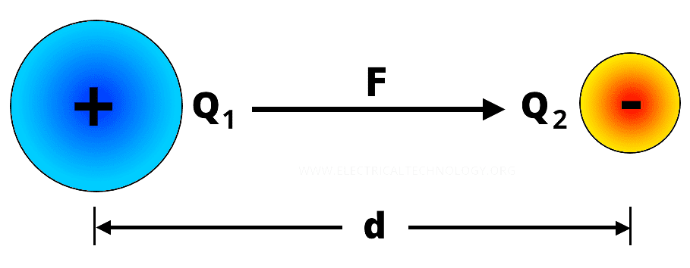
- Coulombs law states that the force between two electric charges is directly proportional to their strengths, inversely proportional to the square of the distance between them and acts along the line joining them.
- Consider the charges of strengths Q, and Q, placed distance d apart. Let F be the force between them
$$F∝\frac{Q_{1}Q_{2}}{d^{2}}$$
$$F=\frac{1}{4π∈ }\frac{Q_{1}Q_{2}}{d^{2}}$$
$$∈is called permittivity of the medium.$$
$$∈ =8.85×{10}^{-12} fad/m$$
- Now, K = $\frac{∈}{∈_{0}}$
Therefore,
$$F=\frac{1}{4π∈_{0}K }\frac{Q_{1}Q_{2}}{d^{2}}$$
$$F=\frac{9 ×{10}^{9}}{K}\frac{Q_{1}Q_{2}}{d^{2}}$$
Electric Field:
- A charge produces some effect in the space around it.
- The region around the charge in which the effect of electric charge is prevailing is called the electric field of the charge.
$E=\frac{F}{q}$ = $\frac{9 ×{10}^{9}}{K}\frac{q}{d^{2}}$
- Unit: NC⁻¹ or Vm⁻¹
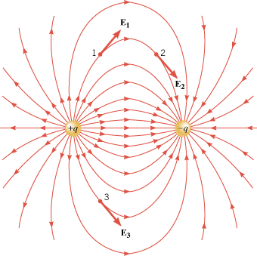
Electric Field lines
- An electric field line is a curve drawn in an electric field in such a way that the tangent to the curve at any point is in the direction of net electric field at that point

Characteristics of Electric Field Line:
- Electric field lines start from positive charges and end at negative charges.
- The tangent drawn at any points on the electric field lines shows the direction of electric field at the point.
- Two field lines never cross each other
- Electric field lines of stationary electric charge distribution do not form closed loops.
- The separation of neighboring field lines in a region at electric field indicates the strength of electric field in that region
Electric Flux
- Electric flux is quantity proportional to the number of electric field lines passing through surface.
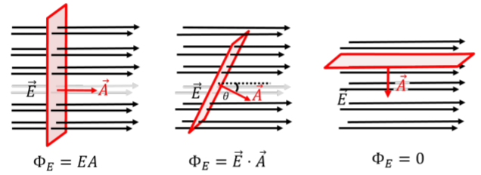
- Consider a surface area A placed in a uniform electric field E. Surface A is perpendicular to E.
- Area A is vector quantity and its direction is along the outward drawn normal to the area. Here, area vector A and E both are in the same direction.
- Therefore, the number of lines passing through surface of area A will be EA. This is an electric flux & associated with the given surface.
- Thus, electric flux is the number of lines passing through the surface. It is represented as φ = Ε Α.
- if the surface of area A is making an angle $θ$ with the direction of electric field E, then to determine the electric flux linked with the surface, we have to consider the Acos$θ$ component of the A parallel (or anti-parallel) to the electric field. Hence, Electric flux linked with the surface is
$$φ = E A cos θ$$
- Electric flux is a scalar quantity. Its SI unit is Nm² C ⁻¹ or V m.
- From equation, it is clear that flux can be positive, negative or zero.
- If the surface is parallel to the electric field, then, A$⊥$E. Hence, the flux linked with surface will be
$$φ = EAcos90° = 0$$
- For $θ$ < 90°, flux is positive and for $θ$ > 90°, it is negative.
Electric current:
- The rate of change of charge is known as electric current.
$$i = \frac{q}{t}$$
- Unit: ampere or C/S

Ohm’s law:
- The voltage across a conductor is directly proportional to the current flowing through it with temperature remains constant.
$$V = IR$$
- It follows linear property
- Temperature is constant

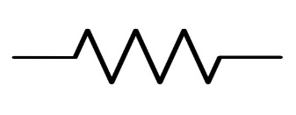
Resistor (R)
- It opposes the flow of electron
- Unit: ohm ($Ω$)

Resistance:
- The property of material to oppose the flow of electron is known as electrical resistance.

Conductance:
- Reciprocal of resistance is known as conductance. It allows to flow electron in conductor
$$σ= \frac{1}{R}$$
- Unit: mho( $Ω^{-1})$

Factors affecting resistance
- It directly proportional to length of conductor
$$R∝l$$
- It inversely proportional to area of conductor
$$R∝\frac{1}{A}$$
- Depends on temperature. As temperature increase resistance increase and vice versa
- It depends on the material
$$R∝\frac{l}{A}$$
$$R = ϱ\frac{l}{A}$$
- $ϱ$ is known as resistivity of material
- Unit of resistivity: $Ω m$
Conductivity $(σ)$
- The reciprocal of resistivity is known as conductivity
$$σ= \frac{1}{ϱ}$$
Unit: $Ω^{-1}/m$

Series connection of resistor | Parallel connection of resistor
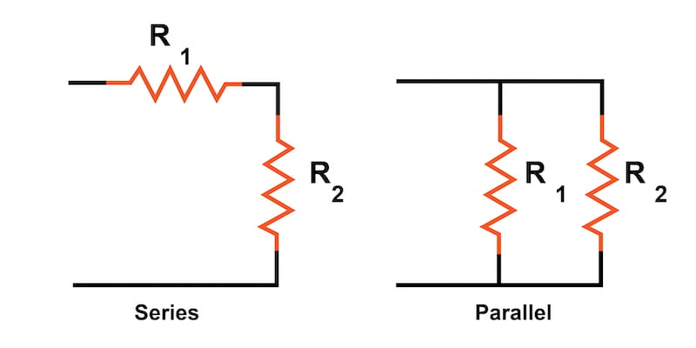
$$R_{eq}=R_{1}+R_{2}$$ | $$R_{eq}=\frac{R_{1}R_{2}}{R_{1}+R_{2}}$$

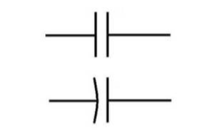
Capacitor and its Capacitance:
A combination of two conductors placed close to each other is called a capacitor.
- One of the conductors is given a positive charge and other is given an equal negative charge.
- For a capacitor the charge Q on the capacitor is proportional to the potential difference V between the plates.
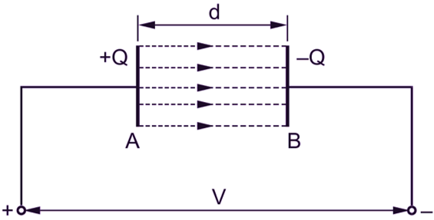
- Thus,
$$Q∝V$$
$$Q = CV$$

- Where proportional constant C is called the capacitance of the conductor. It depends on the shape, size and geometrical placing of the conductors and the medium between them.
- The SI unit of capacitance is coulomb per volt which is written as Farad.
- The symbol F is used for it.
- This is a large, unit and microfarad (µF) is used more frequently

Parallel-Plate Capacitor:
- A parallel plate capacitor consists of two large plane plates placed parallel to each other with a small separation between them.
- Suppose the area of each of the facing surfaces is A and the separation between the two plates is d. Also assume that the space between the plates contains vacuum.
- Let us put a charge Q on one plate and a charge -Q on the other. The charges will appear on the facing surfaces. The charge density on each of these surfaces has a magnitude
$$σ= \frac{Q}{A}$$
- The capacitance of the parallel plate capacitor is
$$C = \frac{ε_{0 A}}{d}$$

Series connection of capacitor | Parallel connection of capacitor
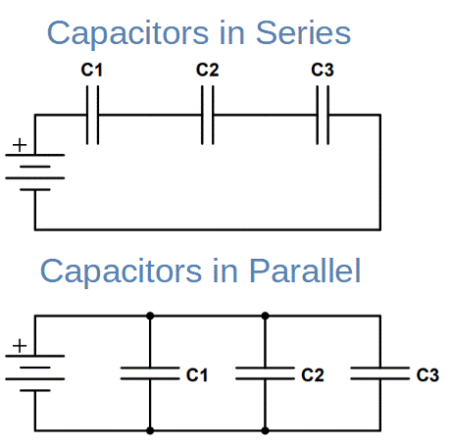
$$C_{eq}=\frac{C_{1}C_{2}}{C_{1}+C_{2}}$$ | $$C_{eq}=C_{1}+C_{2}$$
DDCET questions
 | The SI unit of electric flux is (DDCET 2025)
 | a) | C²/Nm | b) | Nm/C
 | c) | Nm/C² | d) | Nm²/C
 | The electric field lines are (DDCET 2025)
 | a) | Imaginary | b) | Real
 | c) | Ideal | d) | None of the above
 | How many electrons are in 1 coulomb charge? (DDCET 2025)
 | a) | 6.25 × 10¹⁷ | b) | 6.25 × 10¹⁸
 | c) | 6.25 × 10¹⁹ | d) | 6.25 × 10²⁰
 | The capacitance of a capacitor __________ if an insulating dielectric material is placed between two plates of it. (DDCET 2025)
 | a) | Increases | b) | Decreases
 | c) | Remain constant | d) | Become zero
 | If the distance between two charges is doubled then electric force between them becomes (DDCET 2025)
 | a) | Half | b) | Double
 | c) | One fourth | d) | Four times
 | What is the effective value of resistance when three resistors 5 $Ω$ , 10 $Ω , 15 Ω$ are connected in series combination? (DDCET 2025)
 | a) | 10 $Ω$ | b) | 30 $Ω$
 | c) | 20 $Ω$ | d) | 5.5 $Ω$
 | 6V battery is connected across a resistance R. The current through R is 0.4 mA. What will be the value of R ? (DDCET 2024)
 | a) | Nm²/C² | b) | $$\frac{A}{m}$$
 | c) | N/m²C | d) | C²/Nm2
 | The electric flux depends on the (DDCET 2024)
 | a) | Electric field intensity | b) | area
 | c) | Angle between the surface and the electric field | d) | All of these
 | Inverse of resistance is known as (DDCET 2024)
 | a) | Current | b) | Specific resistance
 | c) | Conductance | d) | Voltage
 | What is the effective value of resistance when two resistors 10 $Ω$and 20 $Ω$are connected in parallel combination? (DDCET 2024)
 | a) | 10 $Ω$ | b) | 20 $Ω$
 | c) | 30 $Ω$ | d) | 6.6 $Ω$
 | The formula of capacitance is (DDCET 2024)
 | a) | Q / C | b) | C / V
 | c) | Q / V | d) | C

NOTES

